4th CLIVAR Workshop on the Evaluation of ENSO Processes in Climate Models

**ENSO in a Changing Climate**

*Paris, France, 8-10 July 2015*

Workshop summary and recommendations

*To be submitted to EOS*

*Version 7th Sept. 2015*

The 4th CLIVAR workshop on the evaluation of El Niño / Southern Oscillation (ENSO) processes in climate models was held at Sorbonne-Universités in Paris in July 2015, in conjunction with the UNESCO “Our Common Future Under Climate Change” conference. The workshop, hosted by IPSL and attended by fifty experts including twelve early-career scientists, was organized as part of a new International CLIVAR Research Focus on “ENSO in a changing climate.” The workshop built upon a February 2015 workshop in Sydney, Australia, which focused on ENSO diversity and extremes. It also entrained members of the US CLIVAR working group on ENSO diversity, which has focused attention on understanding the substantial inter-event differences in ENSO mechanisms and impacts (see recent review by Capotondi et al., BAMS 2015). The timing of the Paris workshop was auspicious, as it was concurrent with the development of a strong El Niño in the Pacific, just one year after an aborted El Niño.

Presentations highlighted ENSO mechanisms, the role of intraseasonal variability, climate change and decadal variability, modeling and prediction, and historical and paleo observations. Discussion sessions focused on model evaluation and metrics, and on envisioning future observations as part of the Tropical Pacific Observing System 2020 (TPOS 2020) initiative. The workshop made clear that there is a rich set of observed atmospheric and oceanic phenomena associated with ENSO. The importance of wind variability and of equatorial Pacific clouds and their seasonally-modulated feedbacks with sea surface temperatures (SSTs), were highlighted in several presentations. For example, the SST-wind relationship exhibits marked nonlinearities, with the central equatorial Pacific trade winds having a greater sensitivity to strong El Niños than to either La Niñas or moderate El Niños. The seasonally- and ENSO-modulated advective warming effects of tropical instability waves on the equatorial Pacific cold tongue were also highlighted.

The initial equatorial heat content has traditionally been viewed as an essential precursor for ENSO events. However, a presentation showed that coupled model simulations could spontaneously generate ENSO events without subsurface precursors or large-scale wind triggers, albeit with reduced amplitude. On the other hand, the interplay between westerly wind events and the initial subsurface conditions, whether recharged or in a neutral state, appears to contribute to ENSO diversity by influencing the location of the event along the equator. Intraseasonal atmospheric variability (both westerly and easterly wind events and the Madden-Julian Oscillation) was also addressed in several presentations, highlighting its importance for ENSO predictability. In particular, the temporal sequence of westerly wind events was shown to influence their subsequent impact. For example, a model study indicated that the aborted 2014 El Niño would have developed into a very strong event like that in 1997, had it simply been subjected to the (largely random) sequence of westerly wind events that occurred in April and June of 1997, instead of receiving the strong easterly wind burst that actually occurred in June 2014. Another model study highlighted the importance of off-equatorial wind events for recharging equatorial oceanic heat content, which may have helped to support the development of the 2015 El Niño so close on the heels of the aborted 2014 event. Another study indicated a substantial drop in model forecast skill between 2001-2014, not due to any degradation in the quality of the forecast system, but rather due to weaker signal-to-noise ratio associated with a lack of any strong ENSO events during that time. Such weak-ENSO epochs have occurred in the past, and also can appear at random in unforced simulations from both physical and statistical models of ENSO, with similar impacts on predictability.

Although there is still a large uncertainty about ENSO changes with global warming, most future model projections suggest a future increase in the intensity of the rainfall anomalies associated with ENSO. This results from a projected weakening of the equatorial trade winds and cold tongue, creating a favorable background for eastward and equatorward shifts of atmospheric deep convection. In contrast, observations indicate that the equatorial trade winds strengthened from 2001-2015, to a greater extent than the projections can account for -- even after including the effects of the model intrinsic decadal variability on individual realizations. This begs the question of whether models are missing some important physics of the Pacific response to anthropogenic forcings, and/or whether the models are able to generate a sufficient level of intrinsic decadal variability in the tropical Pacific.

The ENSO modelling session confirmed that although model simulations have improved, their remaining biases, both local and remote to the tropical Pacific, continue to limit our ability to simulate and predict ENSO. One example is the transition zone between the eastern equatorial Pacific cold tongue and the west Pacific warm pool, which occurs too far west in most models — affecting the structure of the wind response and remote teleconnections during ENSO. One presentation showed that increasing the model resolution can reduce many of these biases, but can also reveal previously unrecognized biases in other coupled components. Flux adjustments can be used to mitigate the effects of these biases on ENSO, particularly on the synchronization of ENSO to the end of the calendar year. Despite remaining biases, models continue to be essential tools for understanding and investigating ENSO behavior, especially when observations are limited. Models are particularly helpful for exploring extreme El Niño dynamics, and for distinguishing externally-forced trends from intrinsic low frequency variability.

Several presentations showed how paleo ENSO records offer a unique perspective to explore ENSO low frequency variations. For example, oxygen isotope ratios from living and fossil corals exhibit 60% weaker interannual variability 3-5ka ago, suggesting reduced SST and rainfall variations associated with ENSO. One presentation showed how ENSO’s impacts on SPCZ variability, atmospheric energy transport, and teleconnections can differ between past, present, and future climates – presenting a challenge for attempts to reconstruct past ENSO variability from remote proxy records. Reconstructing historical observations carries challenges of its own, including estimating statistical robustness of trends. For instance, surface pressure observations from Darwin, Australia indicate that ENSO-related variance was particularly weak in the mid-20th century, a signal not seen in some historical SST reconstructions. Novel approaches based on historical atmospheric (e.g. surface pressure) and ocean temperature data have been used to produce climate reanalyses, with three-dimensional dynamical fields going back to the 1800s. These fields indicate that ENSO events prior to the 1950s are poorly resolved in SST-only reconstructions.

Recommendations:

* Understanding ENSO underlying mechanisms is a very active field and should continue to be encouraged.
* The role of intraseasonal variations should be explored further – e.g. how the character of intraseasonal wind events may change in a warmer climate, how these events are modulated by ENSO itself, as well as the degree of their predictability, if any.
* Coordinated simulations (ENSOMIPs) could be performed to further explore several themes discussed during the workshop. The trend vs. decadal variability issue should be discussed with the CLIVAR and CMIP decadal groups, as they are topics of common interest. Assessments of ENSO predictability, evaluating the roles of both large-scale precursors and stochastic wind forcing, would benefit from coordinated simulations. To better understand the teleconnections and impacts of ENSO in a warmer climate, SST-forced atmosphere-only (“AMIP” style) runs could be devised using present-day and projected future SST anomaly patterns, added to a projected future SST climatology.
* Climate model evaluation is a specific task of the CLIVAR Research Focus group, and should involve both the definition of the metrics, and identification of the observations needed (see TPOS recommendations below).
* Work is also needed to improve our ability to interpret changes in oxygen isotope records in paleo observations, in terms of changes in different physical variables, such as water temperature and salinity. Engagement from the atmospheric and oceanographic scientific community in this undertaking is encouraged.
* The role of CLIVAR ENSO research scientists in contributing to ENSO alerts was discussed, and the conclusion was that such alerts are best left to the operational centers.

TPOS recommendations:

* Beyond direct measurements of the tropical Pacific ocean temperatures, surface fluxes, and currents, improved models, assimilation systems, and reanalysis efforts are needed to make optimal use of these observations. In addition, new measurement types, such as salinity and seawater oxygen isotope ratios, would help to constrain coral proxy reconstructions of ENSO’s past, toward understanding ENSO’s future. And in addition to TPOS, it is key to encourage and support the recovery of past observations that have not yet been digitized (e.g. from ships’ logs), as proposed by several on-going community efforts.
* The surface wind stress on the ocean is critical to constraining ENSO air-sea feedbacks and capturing the impacts of equatorial wind bursts on ENSO dynamics and forecasts. Yet there remains surprisingly little convergence among the available observational and reanalysis estimates of the tropical Pacific wind stress. Improved collaboration among satellite and in situ observational communities is urgently needed to resolve these discrepancies.
* Work is also needed to explore what observations are required to improve the physics of the models as well as initialize ENSO forecast models. This will require close collaboration between the ‘Model and Data Assimilation’ task team of TPOS and the CLIVAR Research Focus group.
* There is a need for continued monitoring of the air-sea fluxes of heat, sunlight, momentum, and fresh water, and for dedicated field studies to understand the atmospheric and oceanic building blocks of tropical climate and variability (atmospheric convection and clouds, oceanic upwelling and mixing, diurnal cycle, tropical instability waves, and the space-time structure and nonlinearity of basin-scale feedbacks).
* Although the community would welcome enhanced tropical Pacific moorings with new instrumentation for monitoring ocean-atmosphere interactions, biogeochemical and carbon studies, and other aspects, TPOS should be cautious about making fundamental changes to the moored buoy array configuration, which has proved highly effective in providing a well-calibrated, reliable climate record and in supporting ENSO research and forecasting for the past 30 years.

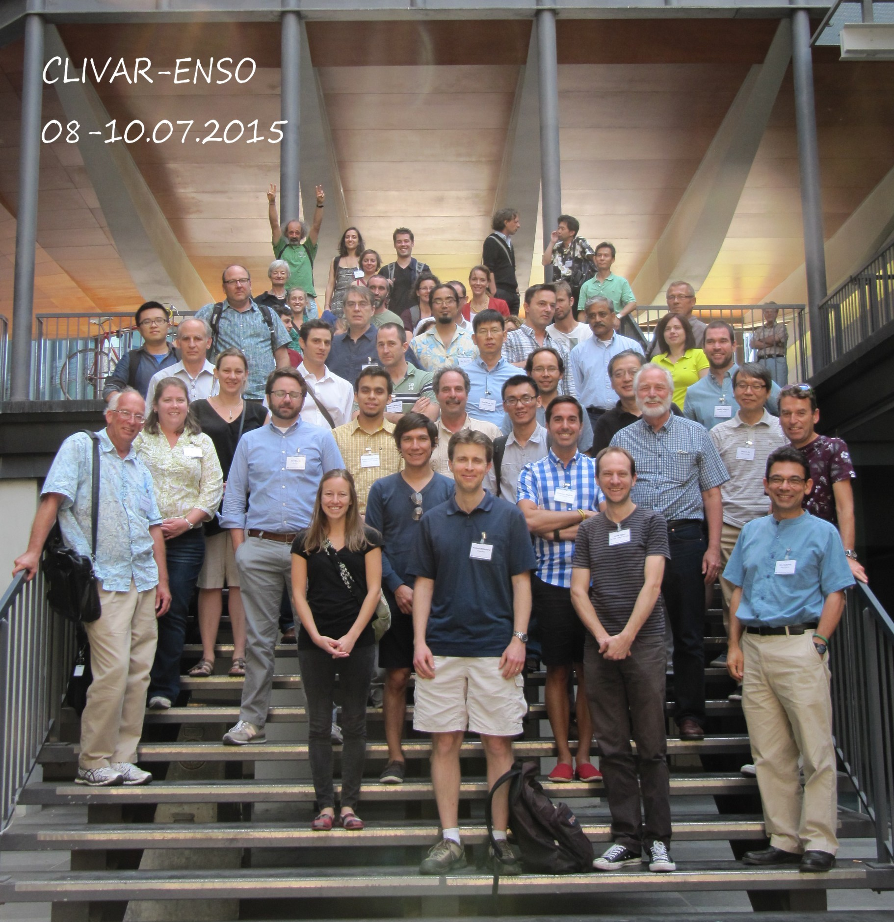

*Photo courtesy Céline Le Helley*