Summary of the side event
A live event was held in INCAE Business School in Costa Rica the 3rd of July 2015, as part of the first World Bank’s Spanish MOOC titled “Bajemos la temperatura - Por qué se debe evitar un planeta 4 ºC más cálido”. The MOOC counted with 6,683 participants registered, representing 87 different countries, 86% of which were from emerging economies. The course provided a synthesis of the most recent scientific evidence related with climate change and presented an analysis of likely impacts and risks, with a focus on developing countries and the Latin America and the Caribbean region. The freely available course utilized many pedagogical elements, including interactive video talks, readings, downloadable resources, quizzes, peer-reviewed assessments, online discussion forums, social media and this interactive side event held in INCAE Business School.

The live event, called “Turn Down the Heat: Confronting the New Climate Normal in Latin America”, was also a side event to the International Scientific Conference “Our Common Future Under Climate Change”, organized by UNESCO during 7-10 July 2015 in Paris. The Side Events to the conference were meant to create links between scientists, governments and civil society in order to develop more bridges between knowledge and solutions, and were designed to reach a broader audience beyond the scientific community. The event could be followed in-person in INCAE Business School (Costa Rica) or through web streaming. A video of the full event was shared later in YouTube with all the global community and it counts already with over 1,500 views. (Link: https://www.youtube.com/watch?v=Mj4I6GA8MxY&feature=youtu.be&t=9m)

The science behind climate change and the policy-related discussions have generated significant interest in the region and renowned experts joined the event as panelists, such as: Patricia Ramírez (Executive Secretary of the Regional Committee for Water Resources, Costa Rica); Raffaele Vignola (Director of the Latin American Chair of Environmental Decisions for Global Change at CATIE, Costa Rica); Fernando Tudela Abad (Former Vice Minister for Planning and Environmental Policy and Principal Negotiator of Climate Change Issues, Planning and Environmental Policy for the Ministry of Environment and Natural Resources, Mexico); Pascal Girot (Coordinator and Senior Policy Advisor on Climate Change in MINAE, Costa Rica); Ana Maria Majano (Associate Director of the Latin American Center for Competitiveness and Sustainable Development at INCAE Business School, Costa Rica); Erick Fernandes (Adviser of Agriculture, Land Management, Forestry, and Global Climate Change at the World Bank Group, United States), and Pablo César Benítez (Senior Economist at the World Bank Group, United States).

Key messages and results
The event “Turn Down the Heat: Confronting the New Climate Normal in Latin America” aimed to explain to a broader audience the science behind climate change, providing the latest data and evidences, and explored different actions and policies to adapt and mitigate climate change in the Latin America and the Caribbean region.
The event was divided into two main parts. The first part, “Science and Impacts”, introduced the main findings of the “Turn Down the Heat” reports and the panelists explained climate change impacts across different sectors in the LAC region. Some of the key messages in this segment were related to climate impacts on water resources, extreme weather events, agriculture and food security, and sea level rise. During the second part, ”Adaptation and Mitigation Strategies”, panelists presented and discussed a suite of policy responses to climate change and special attention was given to renewable energy, policy incentives, carbon pricing, climate finance, integration of mitigation and adaptation, and decarbonization pathways. Several case studies, such as the carbon tax in Mexico, were discussed more in depth to provide real life examples. Finally, at the end of each section, panelists answered questions from the live audience, enhancing the dialogue between the scientific community, government officials and civil society.
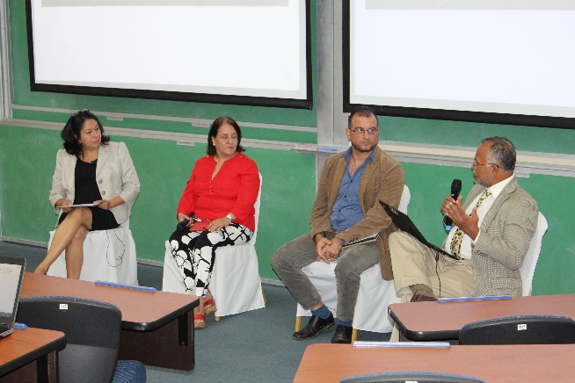 | 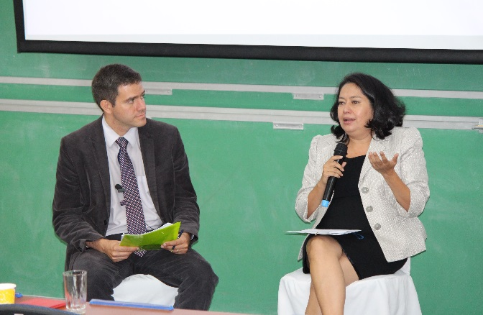
Event “Turn Down the Heat: Facing a New Climate Reality”, INCAE Business School, 3 July 2015.

Follow-up actions
The World Bank Group is committed to the challenge of keeping a global increase in temperature below 2 degrees Celsius. In that sense, it has been integrating climate change considerations into its investment and operations decisions during the last decade and will keep doing it during the next ones.

A great amount of projects and activities can be considered as follow up steps/actions to this side event in INCAE Business School. Among them you can find few examples below:
- Participation in the organization of the Latin American and Caribbean Carbon Forum (LACCF) that promotes knowledge and information sharing while facilitating business opportunities among main climate finance and emission market stakeholders.
- Organization, design and participation in the LEDS GP and LEDS LAC 2015 annual events which aim to conduct peer learning and in depth training on LEDS, share lessons and innovations on LEDS across countries and programs, and advance collaboration across countries.
- Another enhanced delivery of the MOOC “Bajemos la temperatura - Por qué se debe evitar un planeta 4º C más cálido” in 2016. This second delivery will analyze more in depth the impacts and the adaptation and mitigation actions in the Latin America region, and will put a special emphasis on the COP21 discussions and outcomes.

